

**User Guide**

**SITE NAME: Neuro Sensum**

**CREATED ON: 06/Jun/2018**

# Table of Contents

Table of Contents 2

1. Website Login 3

2. Theme/Site options 4

Customize 4

Theme Options 5

Footer Settings 5

Website Menu Management 7

Home Page 9

Services Page 14

Case Studies Page 17

Contact Page 20

Careers Page 22

Blog Template 25

Adding new blog post 27

Editing existing blog post 27

Adding New Category 28

# 

# Website Login

|  |  |
| --- | --- |
| **Site URL** | http://neurosensum.acodez.ca |
| **Admin URL** | http://neurosensum.acodez.ca/wp-admin/ |
| **Username** | neuuSrename |
| **Password** | LqQ*FAmB6&1@ApXDvF |

# Theme/Site options

This section will help you with information on the **basic/common settings** of the website including logo, favicon, social links, contact email etc.

## Customize

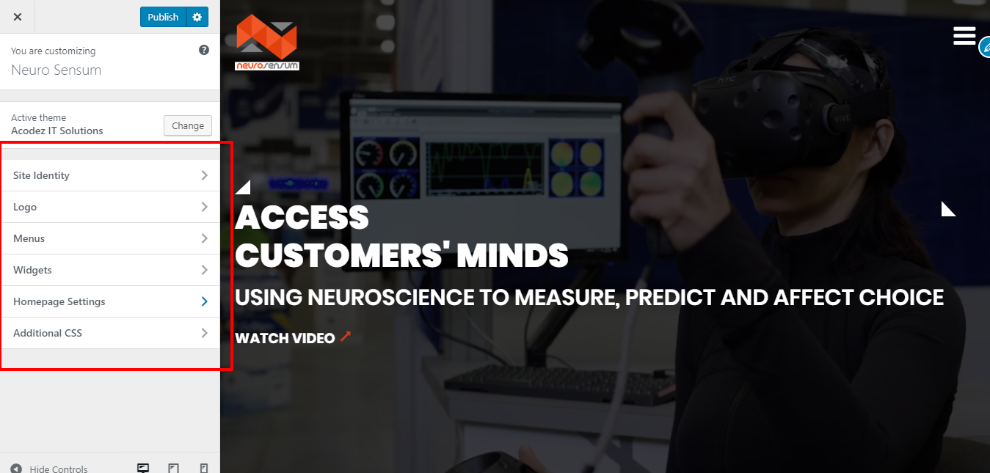

**Path:** Backend of website >> Appearance >> Customize

Here you can edit the logo, favicon, site title, site description etc. Once you have done the changes, you can save the same by clicking the Blue button (Save) on the top of the screen.

## Theme Options

**Path:** Backend of website >> Theme Options >> Theme Options

Here you can have options to add the mail ids for contact and career forms,Add the header video and its details,Keys for recaptcha in contact form .

Once you have done the changes, you can save the same by clicking the Blue button (Update) on the top of the screen

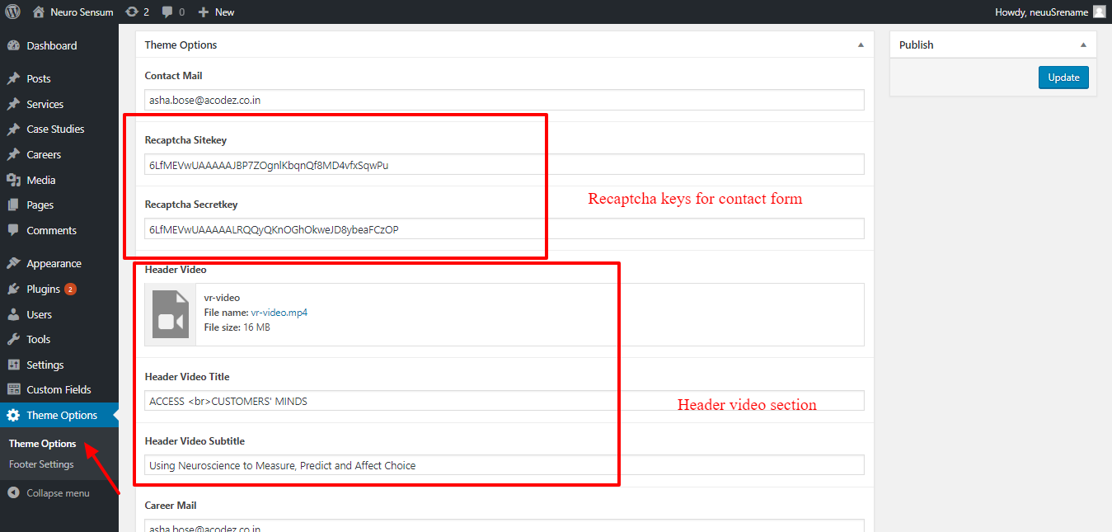

## Footer Settings

**Path:** Backend of website >> Theme Options >> Footer Settings

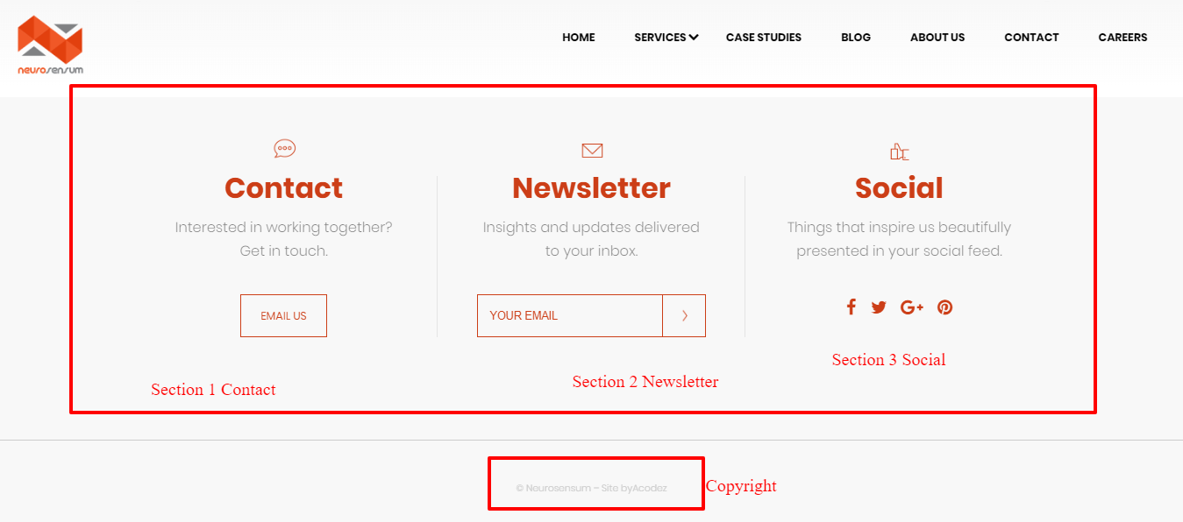

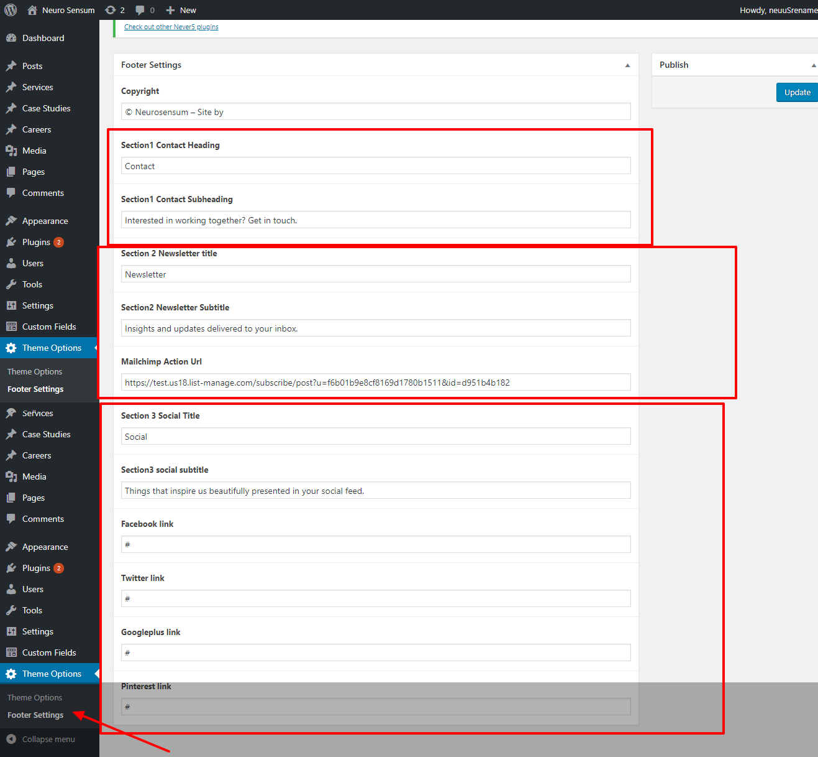

**Path:** Backend of website >> Theme Options >> Footer Settings

Once you have done the changes, you can save the same by clicking the Blue button (Update) on the top of the screen

# Website Menu Management

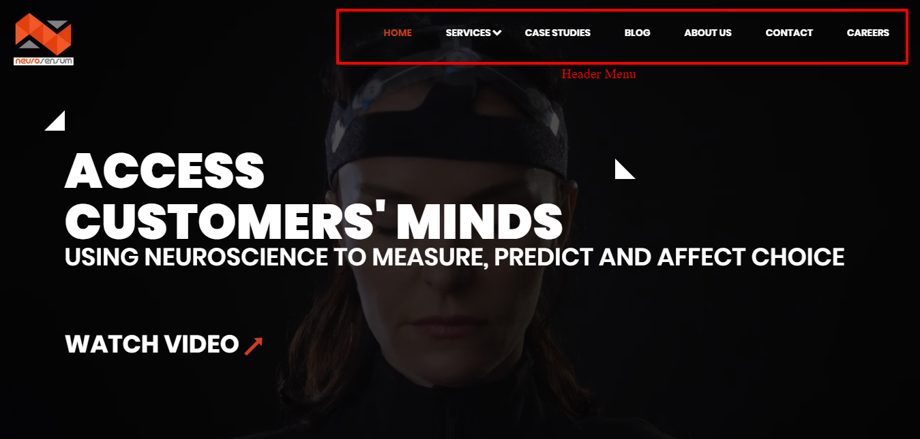

**Path:** Backend of website >> Appearances >> Menus

Once you have done the changes, you can save the same by clicking the Blue button (Save Menu) on the top of the screen

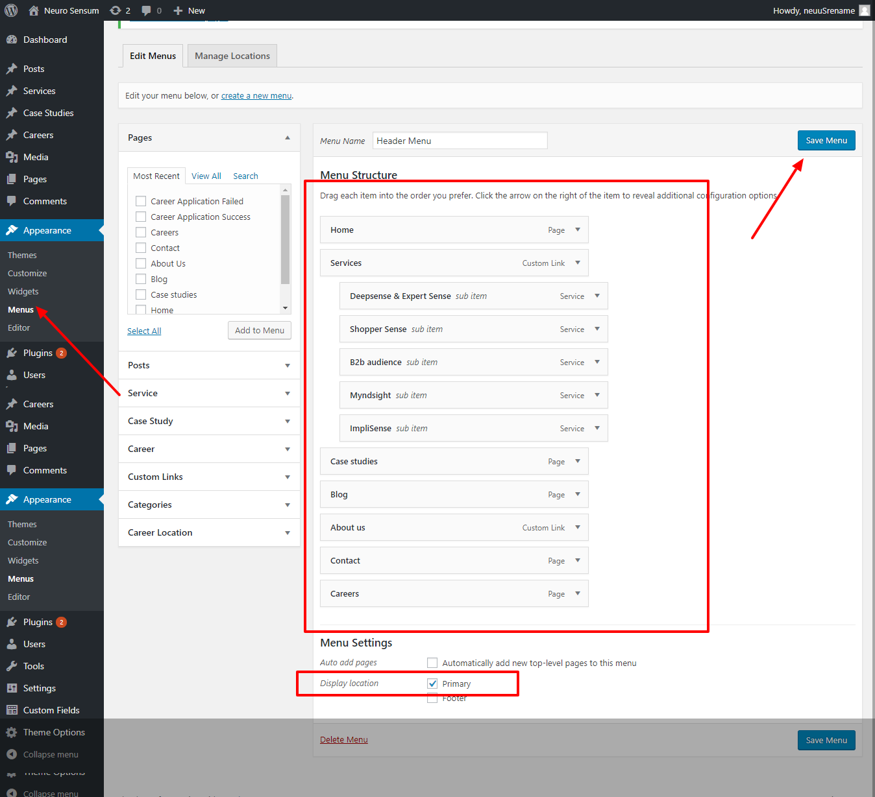

# Home Page

**Path:** Backend of website >> Pages >> All Pages >> Home

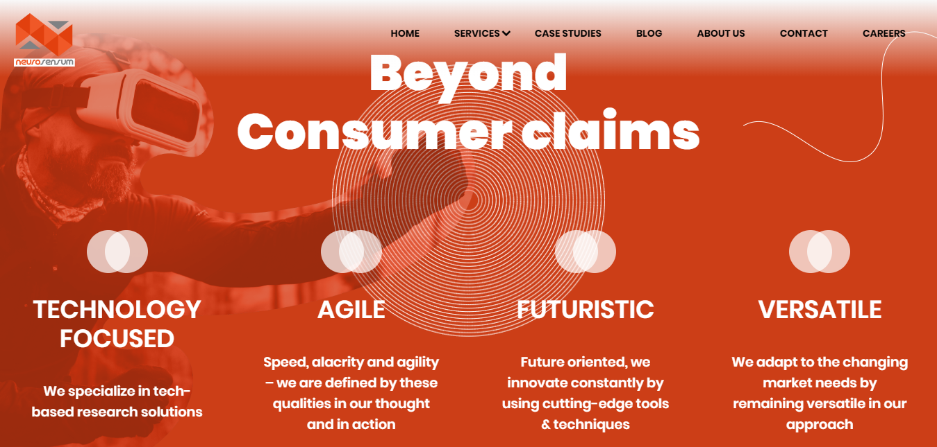

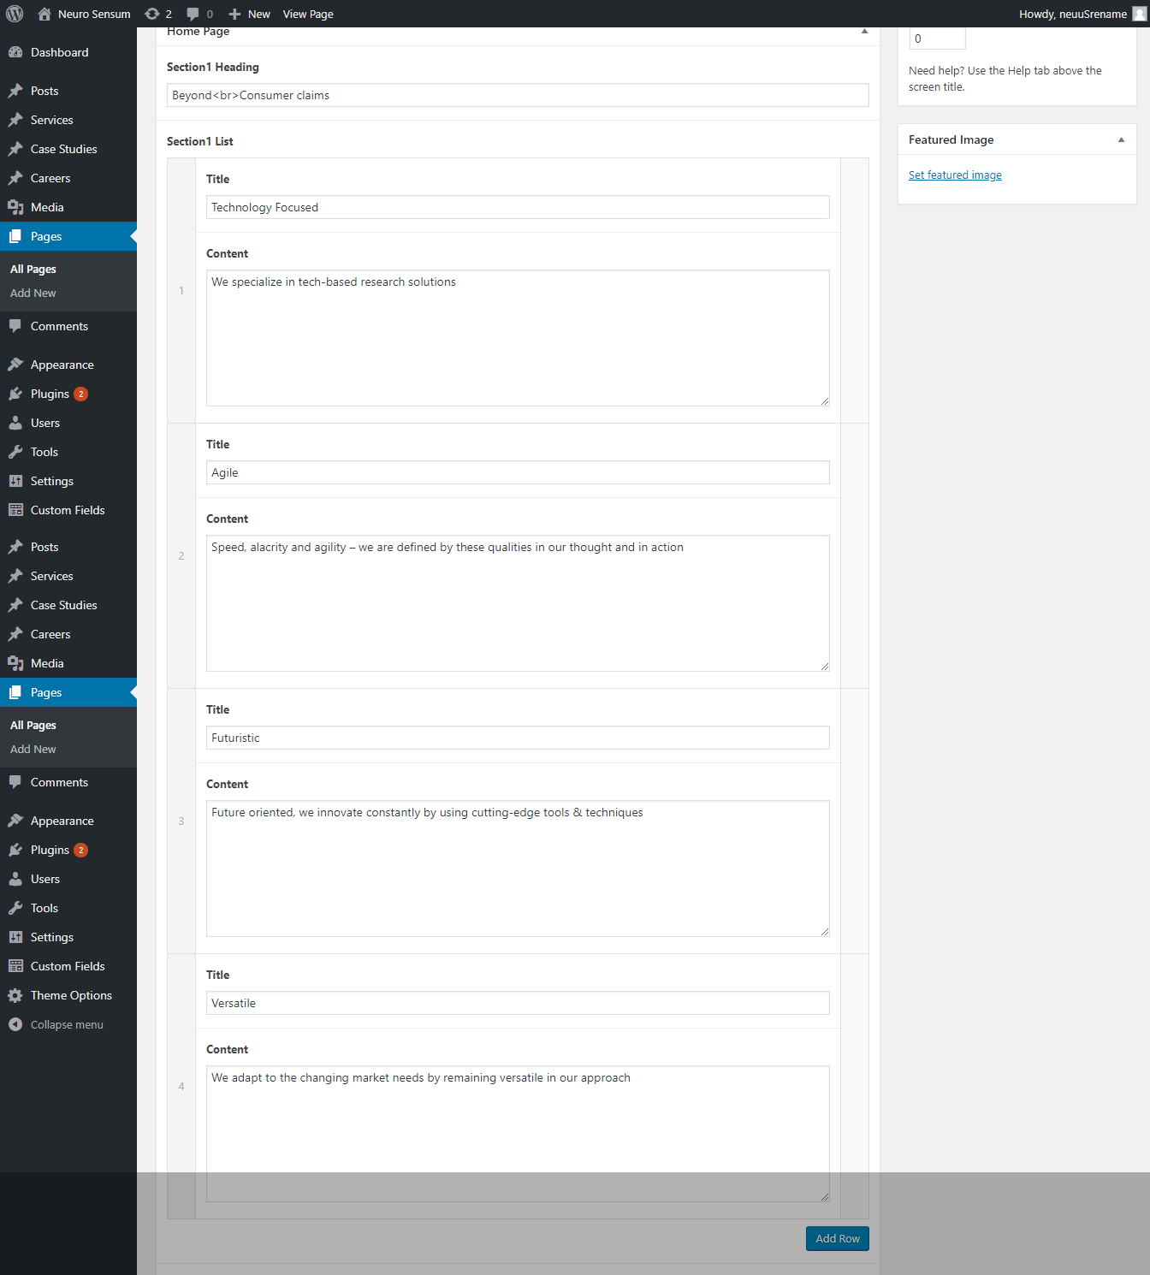

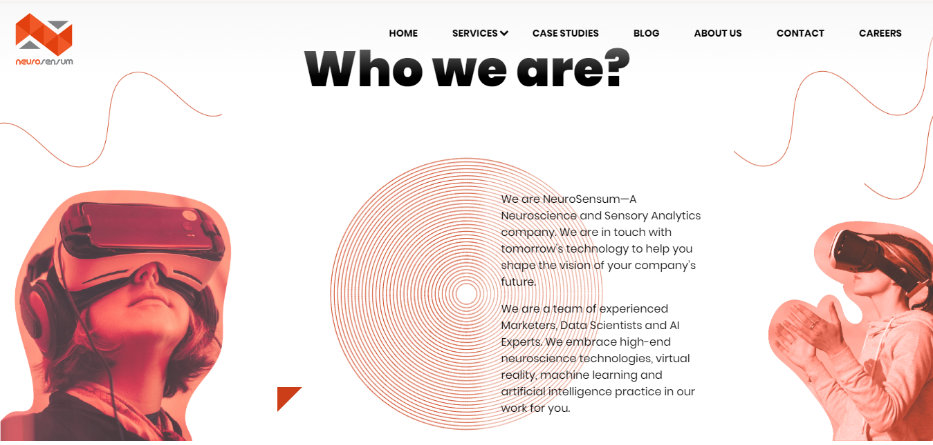

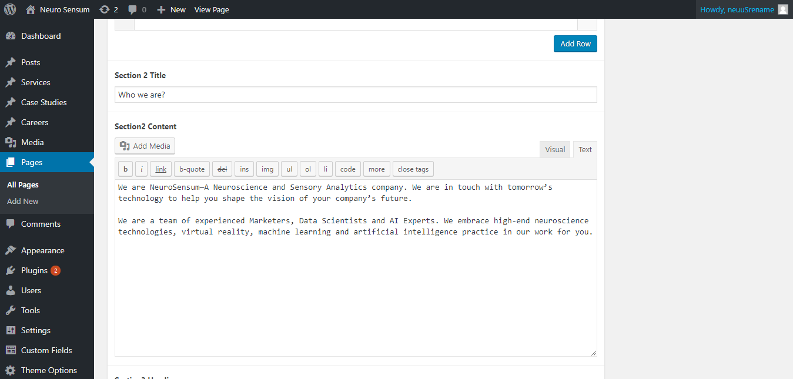

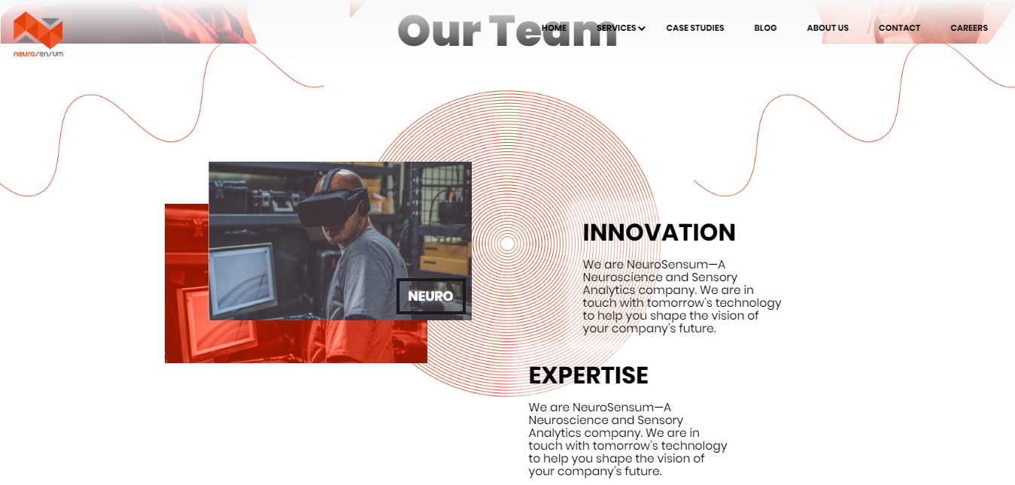

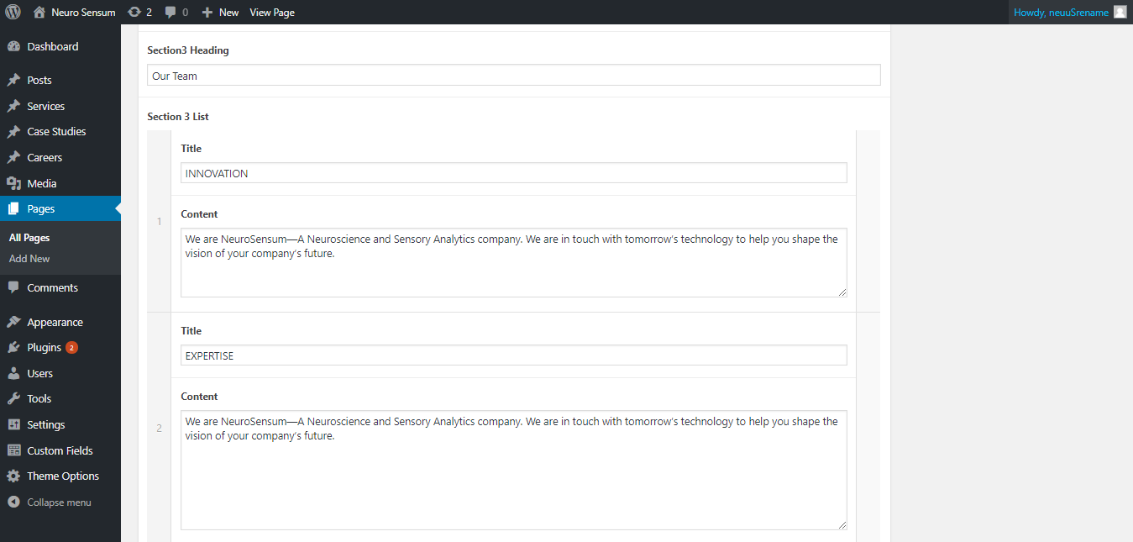

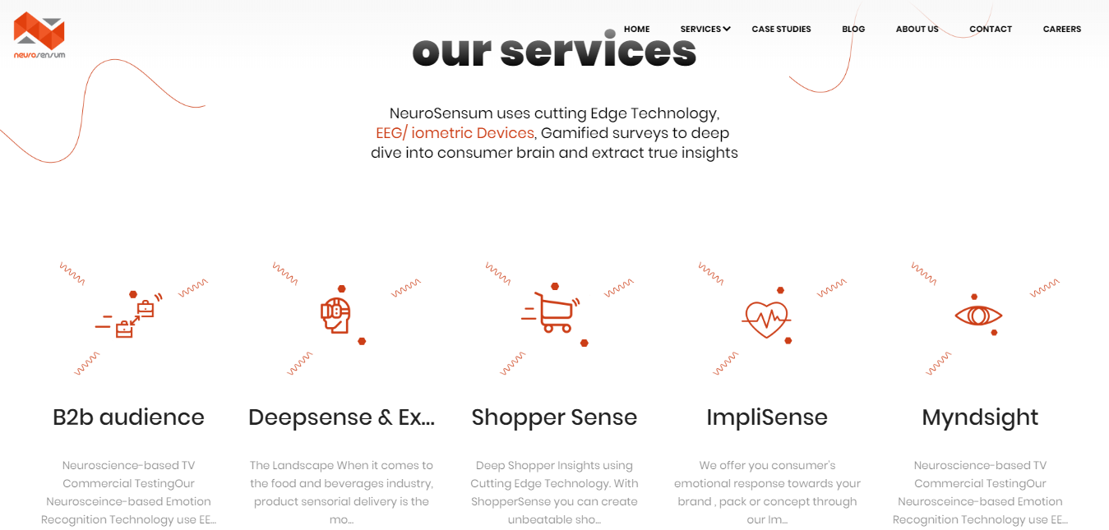

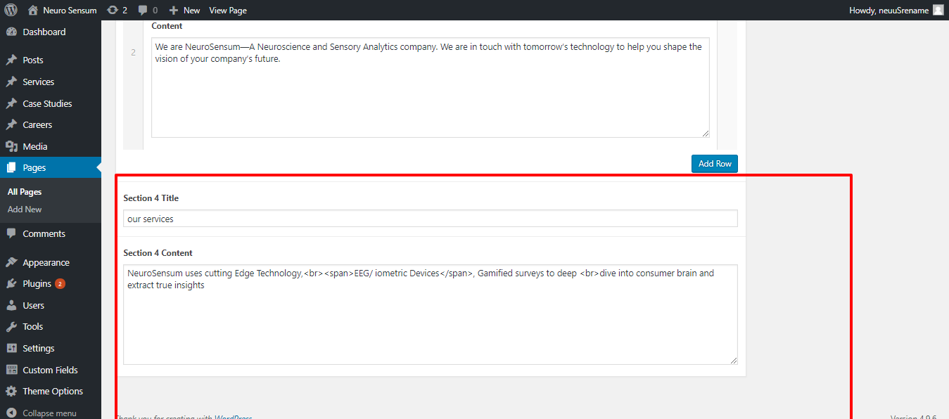

Once you have done the changes, you can save the same by clicking the Blue button (Update) on the top of the screen

# Services Page

To Manage the services

**Path:** Backend of website >> Services >> All Items

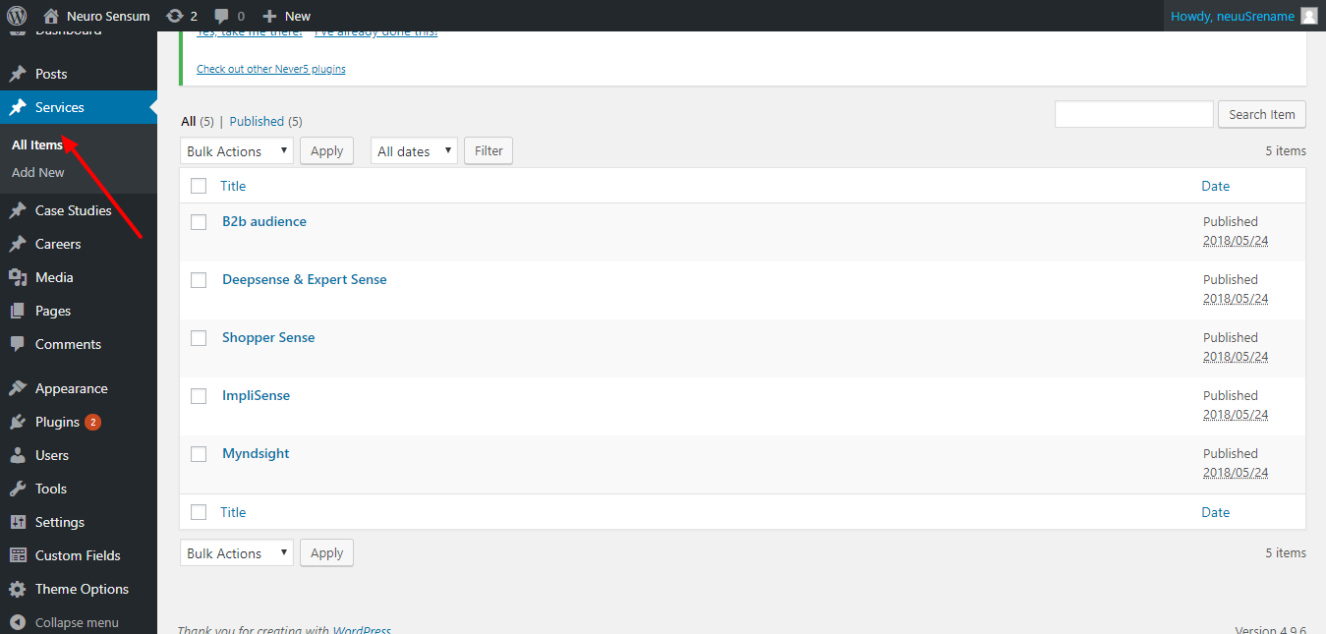

Click on the corresponding service you wish to edit or Click on **Add New** for new Service

You can also use **Services=>Add New** for adding a new career

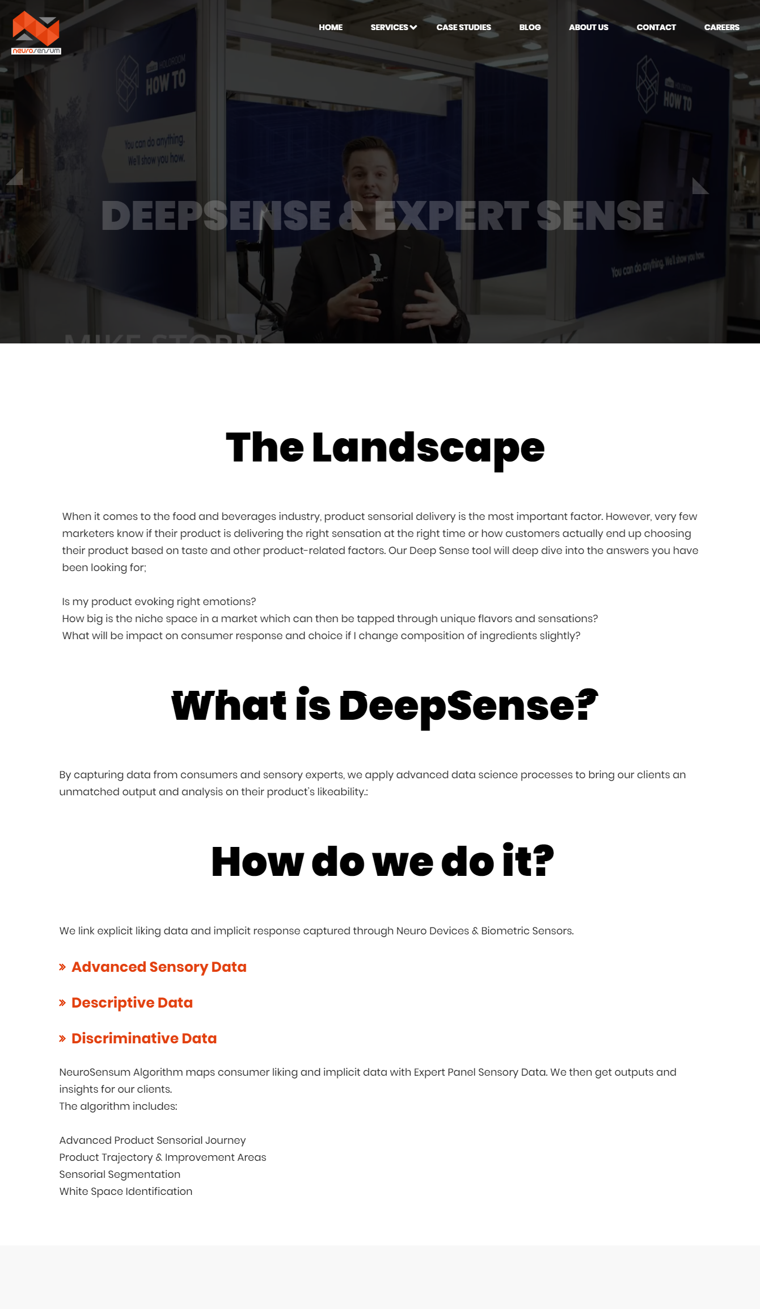

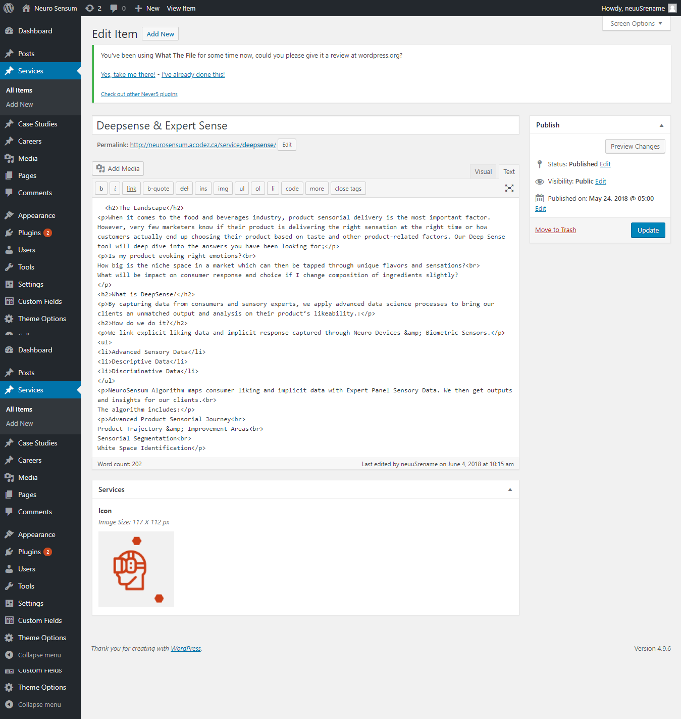

Once you have done the changes, you can save the same by clicking the Blue button (**Update/Publish**) on the top of the screen

# Case Studies Page

To Manage the case studies

**Path:** Backend of website >> Case Studies >> All Items

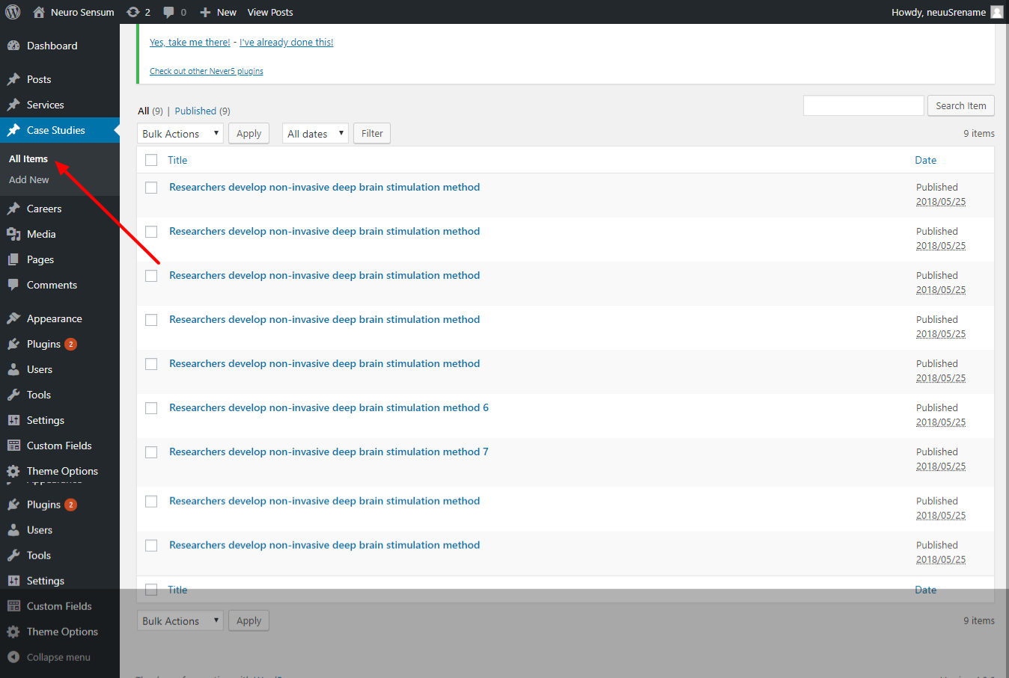

Click on the corresponding case study you wish to edit or Click on **Add New** for new Case study

You can also use **Case Studies=>Add New** for adding a new career

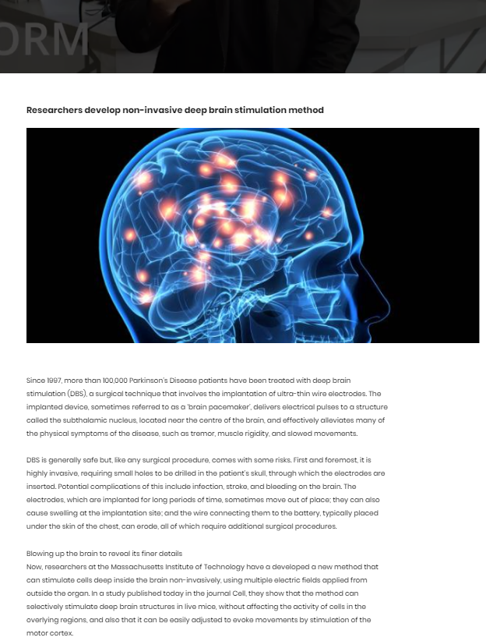

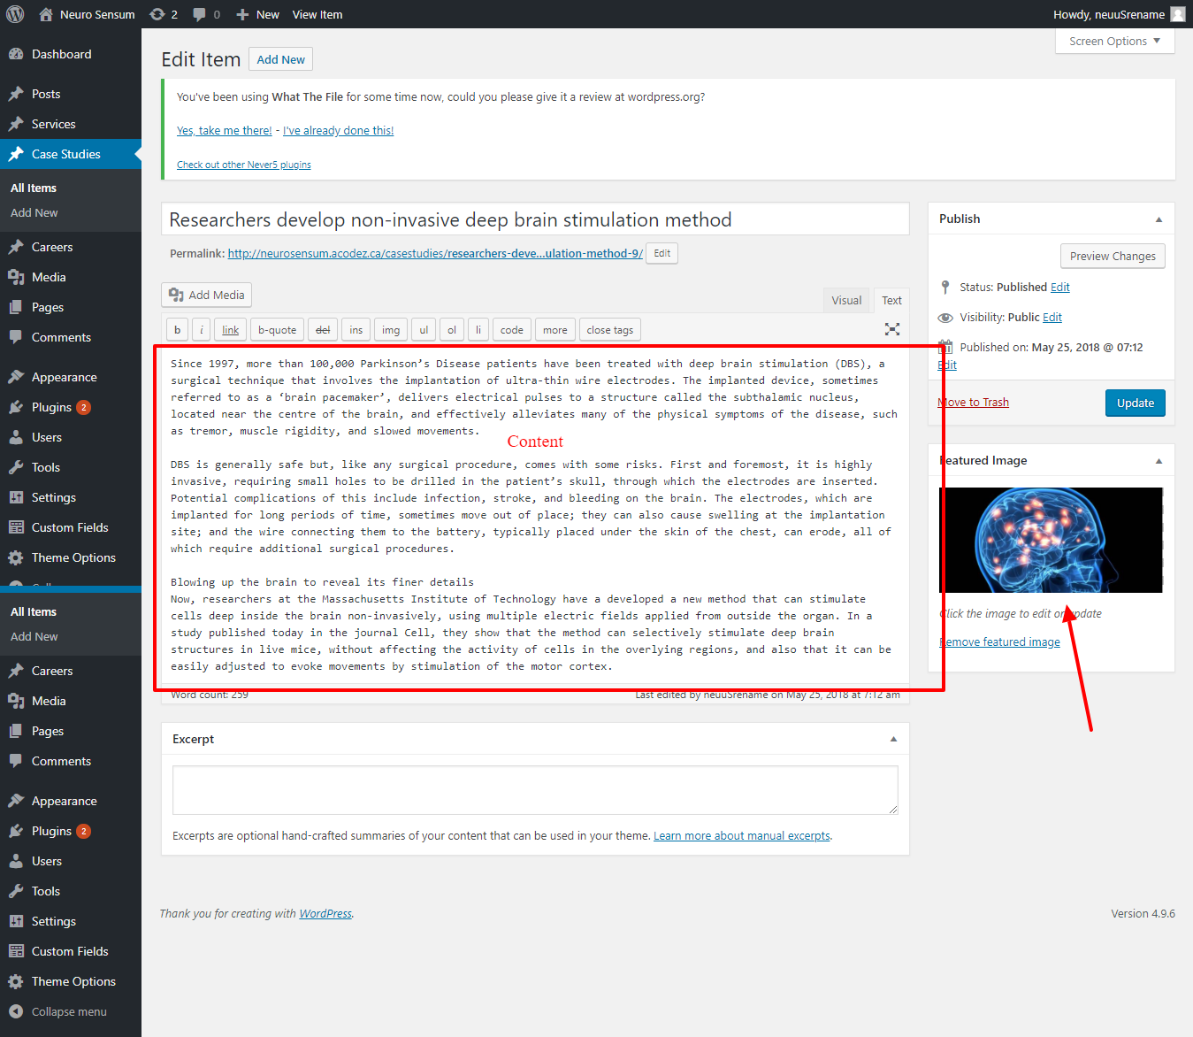

Once you have done the changes, you can save the same by clicking the Blue button (**Update/Publish**) on the top of the screen

# Contact Page

**Path:** Backend of website >> Pages >> All Pages >> Contact

You can contact the site through the contact form.An email acknowledgement will be sent to the customer.An email with the details entered in the form will be sent to the contact mail mentioned in the **Theme Options**

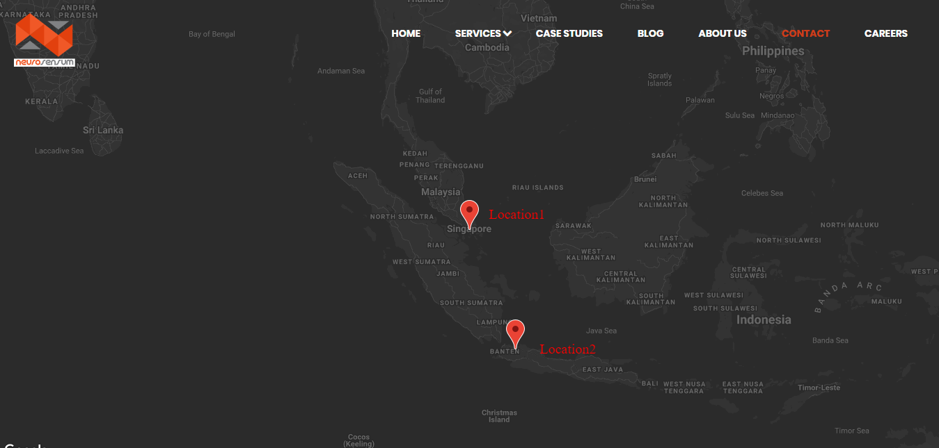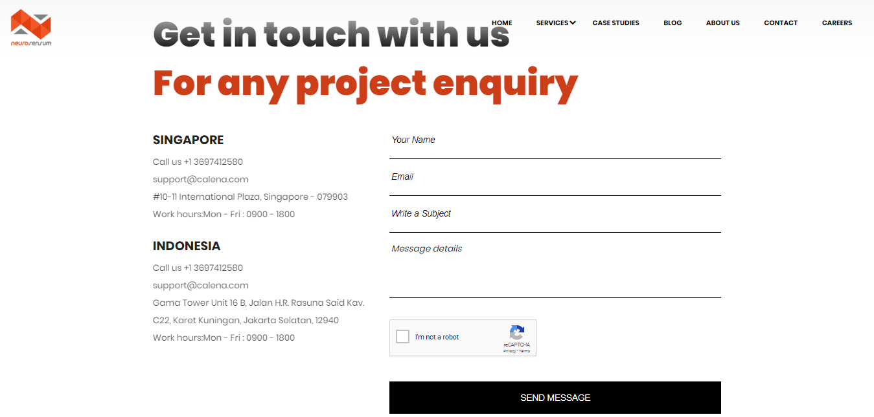

Once you have done the changes, you can save the same by clicking the Blue button (**Update**) on the top of the screen

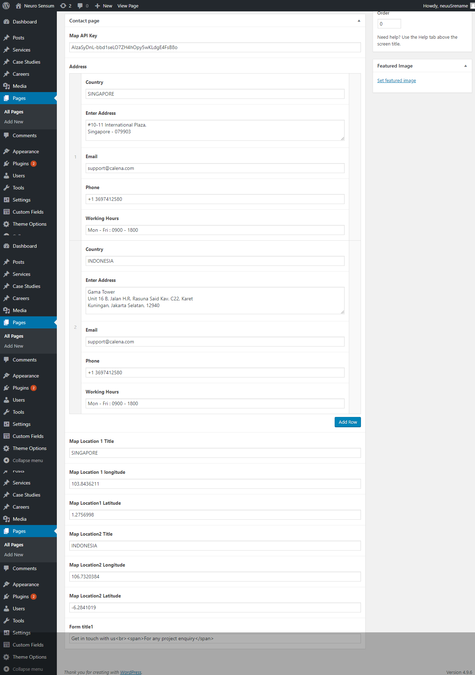

# Careers Page

To Manage the careers

**Path:** Backend of website >> Careers >> All Items

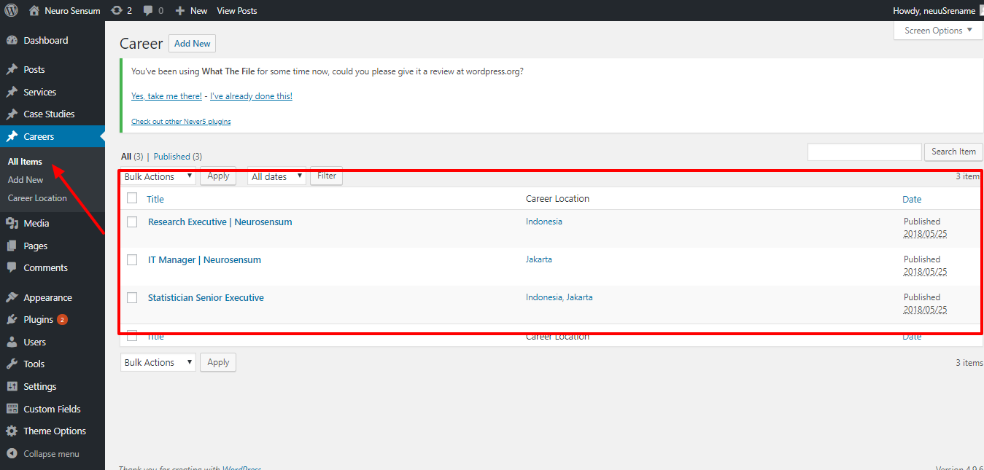

Click on the corresponding career you wish to edit or Click on **Add New** for new Career

You can also use **Careers=>Add New** for adding a new career

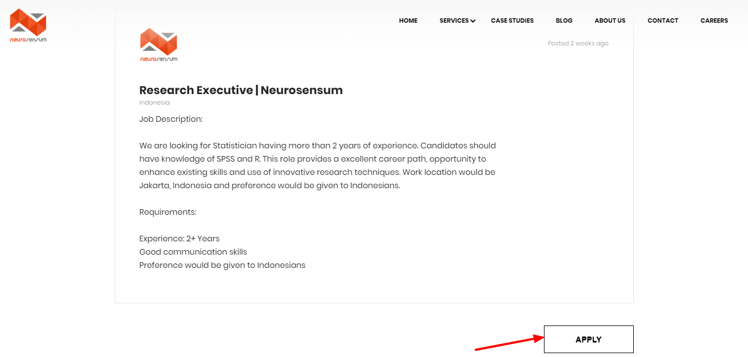

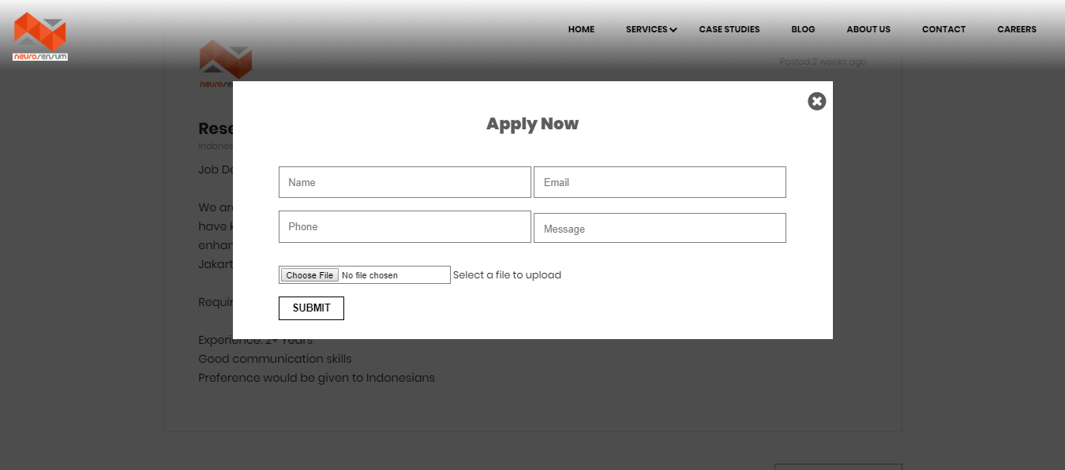

You can apply for carrer opening through the form shown by clicking the **Apply** Button in the career detail page.

An email acknowledgement will be sent to the candidate/customer.

An email with the details entered in the form along with the attachment, will be sent to the career mail mentioned in the **Theme Options**

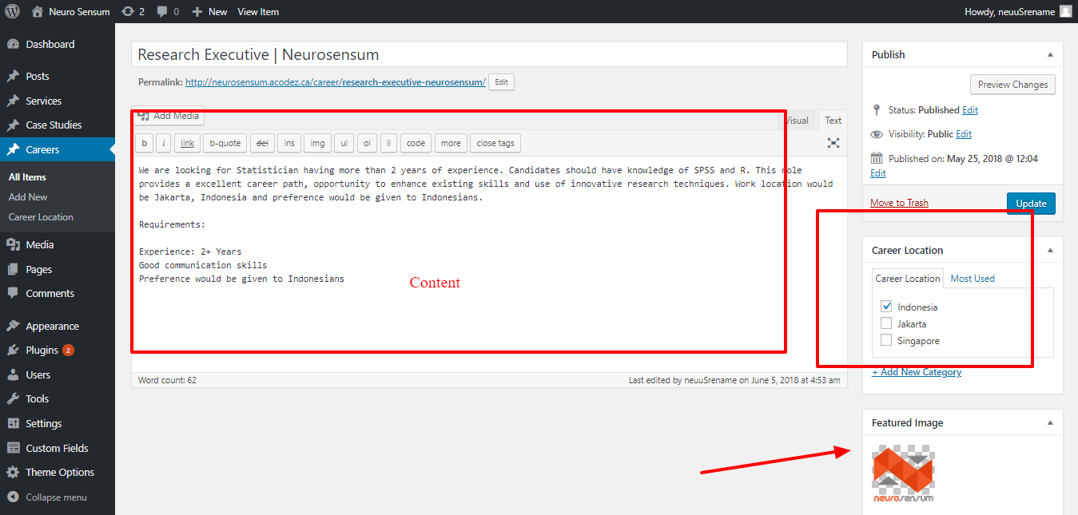

Once you have done the changes, you can save the same by clicking the Blue button (**Update/Publish**) on the top of the screen

# Blog Template C:\Users\Asha Bose\Desktop\Neurosensum\28.png

## Adding new blog post

**Path:** Backend of website >> Posts >> Add New

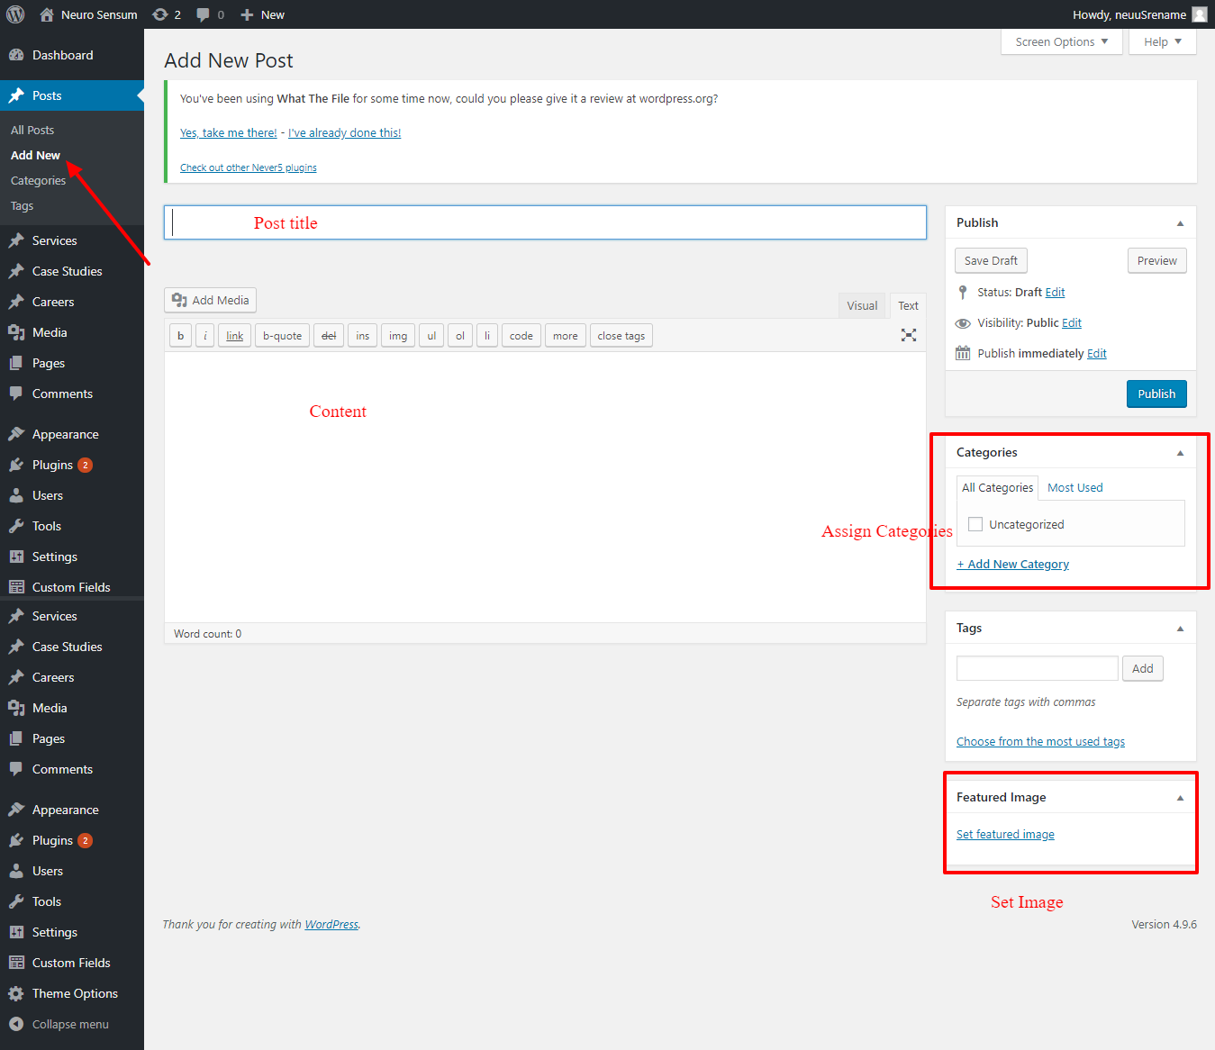

Once you have added the contents, you can save the same by clicking the Blue button (**Publish**) on the top of the screen

## Editing existing blog post

**Path:** Backend of website >> Posts >> All Items

Click on the corresponding post you wish to edit

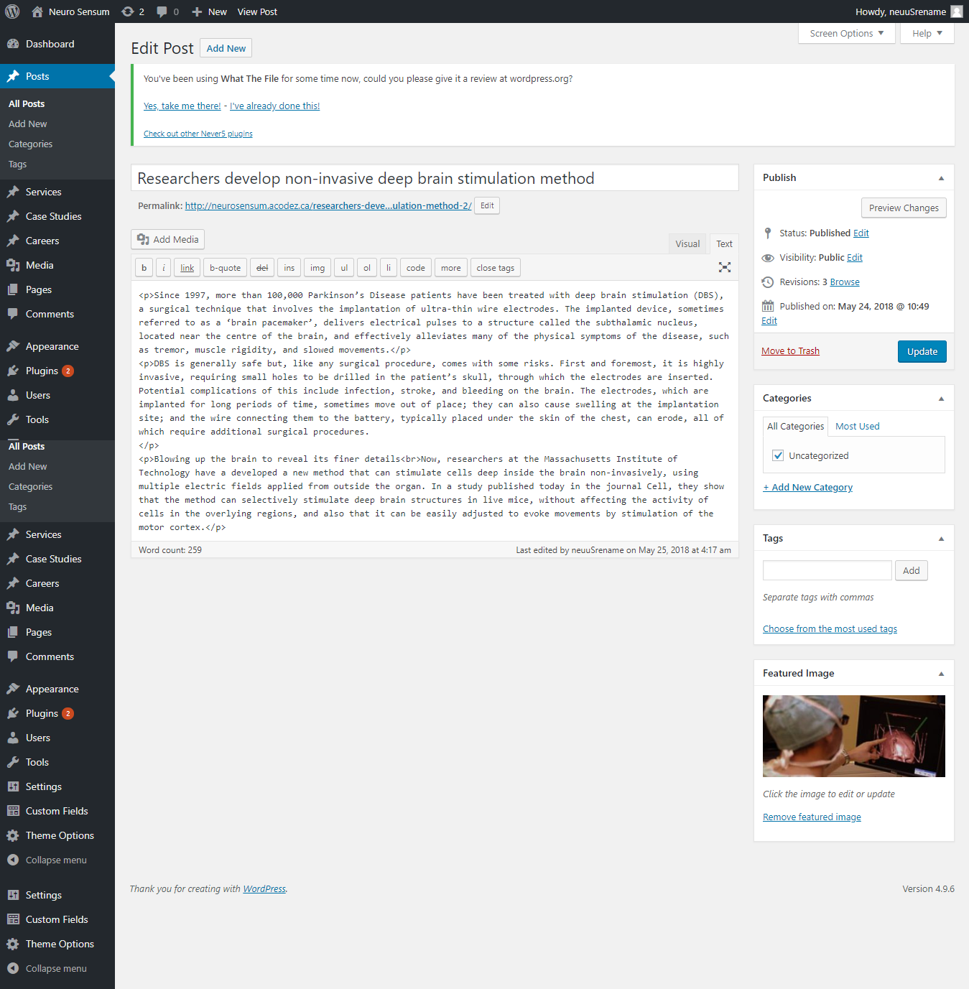

Once you have done the changes, you can save the same by clicking the Blue button (**Update**) on the top of the screen

## Adding a new Category

**Path:** Backend of website >> Posts >> Categories

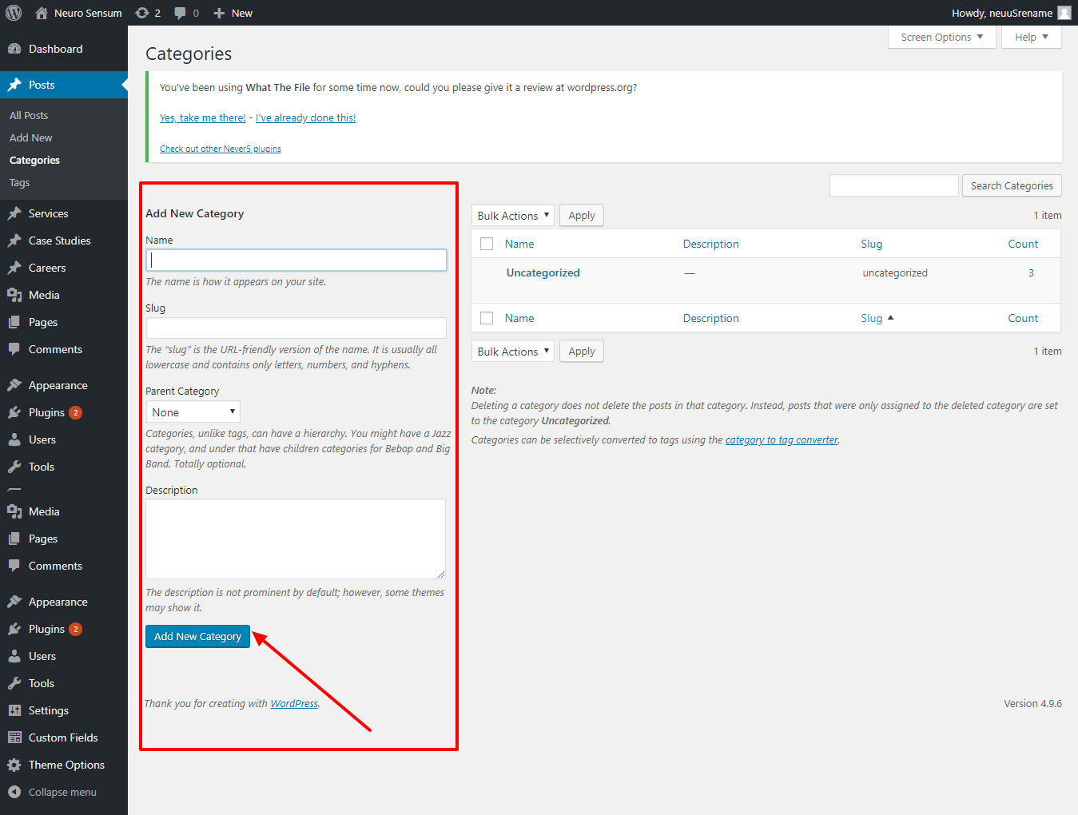

Once you have done the changes, you can save the same by clicking the Blue button (**Add New Category**)

**-Thank You-**